ADAPTIVE ENSEMBLE MACHINE LEARNING FRAMEWORK FOR TIME-SERIES SPECTRUM OCCUPANCY PREDICTION IN COGNITIVE RADIO NETWORKS.

A PROJECT REPORT
submitted by
CB.EN.U4ELC24006 AKSHITA MURALI
CB.EN.U4ELC24014 DHARSHAVARDHAN UM
CB.EN.U4ELC24031 S DHEVAN
CB.EN.U4ELC24058 SUBASHREE A

in partial fulfillment of

BACHELOR OF TECHNOLOGY

IN

ELECTRICAL AND COMPUTER

ENGINEERING



AMRITA SCHOOL OF ENGINEERING, COIMBATORE

AMRITA VISHWA VIDYAPEETHAM

COIMBATORE- 641112

March 2026

AMRITA SCHOOL OF ENGINEERING, COIMBATORE
AMRITA VISHWA VIDYAPEETHAM
COIMBATORE CAMPUS



BONAFIDE CERTIFICATE

This is to certify that the project entitled “ADAPTIVE ENSEMBLE MACHINE LEARNING FRAMEWORK FOR TIME-SERIES SPECTRUM OCCUPANCY PREDICTION IN COGNITIVE RADIO NETWORKS” submitted by
CB.EN.U4ELC24006 AKSHITA MURALI
CB.EN.U4ELC24014 DHARSHAVARDHAN UM
CB.EN.U4ELC24031 S DHEVAN
CB.EN.U4ELC24058 SUBASHREE A

in partial fulfillment of the requirements for the subject 23ELC212- MACHINE LEARNING in Bachelor of Technology in ELECTRICAL & COMPUTER ENGINEERING is a bonafide record of the work carried out under my guidance and supervision at the Department of Electrical and Electronics Engineering, Amrita School of Engineering, Amrita Vishwa Vidyapeetham, Coimbatore Campus.

Mr. Nakkeeran M
Faculty In-Charge,
Assistant Professor (OC),
Department of Electrical and Electronics Engineering,
Amrita Vishwa Vidyapeetham, Coimbatore Campus,
India.

This project report was evaluated by us on (date)

INTERNAL EXAMINER EXTERNAL EXAMINER

Contents
Acknowledgements
List of figures vi
List of tables vii
Abbreviations viii
List of symbols ix
Abstract x
1 Introduction 1
1.1 Background 1
1.2 Problem Statement 1
1.3 Objectives 1
1.4 Research Gap 1
1.5 Contributions of the Project 1
2 Related Works 2
2.1 Introduction 2
2.2 Machine Learning for Spectrum Prediction 2
2.3 Time-Series Based Spectrum Prediction 2
2.4 Ensemble Learning Approaches 2
2.4.1 Gap Analysis 2
2.5 Justification for Proposed Approach 2
3 Proposed Approach 3
3.1 Proposed Framework
3.2 Dataset Details
3.3 Research Approach 3
4 Methodology
4.1 Machine Learning Techniques
4.2 Evaluation Metrics
5 Implementation And Results
5.1 Setup
5.2 Data Preprocessing
5.3 Experimental Procedures
5.4 Results
6 Result Discussion
6.1 Insights from Results
6.2 Implications
6.3 Limitations
7 Conclusion And Scope For Future Work
7.1 Summary
7.2 Contributions
7.3 Limitation
7.4 Takeaway
7.5 Future Scope
Appendix
Dataset description and pre-processing details
References

List of Figures
3.1 General workflow of the spectrum data analysis
5.2 Correlation matrix
5.2 Distribution of spectrum occupancy
6.1 Comparison of ROC Curves
6.1 Comparisons of Accuracy

List of Tables

6.1 Accuracy comparison of different classification models
A.2 Attributes

Abbreviations
ML | Machine Learning
CR | Cognitive Radio
CRN | Cognitive Radio Network
PU | Primary User
SU | Secondary User
SNR | Signal-to-Noise Ratio
RF | Radio Frequency
PSD | Power Spectral Density
TP | True Positive
TN | True Negative
FP | False Positive
FN | False Negative

List of symbols

$$x_{i}$$ | $i^{th}$data sample

$$y_{i}$$ | Actual class label

$$\hat{y_{i}}$$ | Predicted class label

$$N$$ | Total number of samples

$$f$$ | Frequency

$$t$$ | Time

$$SNR$$ | Signal-to-noise ratio

$$μ$$ | Mean value

$$σ$$ | Standard deviation

Abstract

The rapid growth of wireless communication technologies and connected devices has led to significant pressure on the available radio spectrum. Traditional static spectrum allocation methods often result in inefficient utilization of licensed frequency bands, where many channels remain underutilized for long periods. CRNs provide an intelligent solution to this problem by allowing secondary users to dynamically access unused portions of the spectrum without causing interference to primary users. However, predicting spectrum availability accurately is a challenging task due to the highly dynamic and time-varying nature of wireless environments.This project proposes an adaptive ensemble machine learning framework for time-series spectrum occupancy prediction in cognitive radio networks. The framework utilizes historical spectrum sensing data to learn temporal patterns in spectrum usage and forecast future occupancy states. Initially, the dataset undergoes preprocessing steps including data cleaning, normalization, and handling of missing values. Feature extraction techniques are then applied to capture important temporal characteristics of spectrum behavior. Multiple machine learning algorithms are trained individually to model the spectrum occupancy patterns. These models are combined using an ensemble learning strategy to improve prediction reliability and reduce model bias.The proposed framework is implemented using Python and evaluated in a cloud-based environment named Google Colab. Performance is measured using standard evaluation metrics including accuracy, precision, recall, F1-score, and prediction error rate. Experimental results demonstrate that the ensemble learning approach provides better prediction performance compared to individual models by effectively combining their strengths.The proposed system enables more efficient spectrum utilization by predicting channel availability in advance, allowing secondary users to make intelligent spectrum access decisions. This research contributes toward improving dynamic spectrum management in next-generation wireless communication systems and highlights the potential of machine learning techniques for intelligent spectrum prediction.
Keywords: Cognitive Radio Networks, Spectrum Prediction, Ensemble Learning, Time-Series Analysis, Machine Learning, Dynamic Spectrum Access

Chapter 1

Introduction

Background
Despite advancements in cognitive radio technology, accurate prediction of spectrum availability remains a challenging problem. Wireless spectrum usage is highly dynamic and influenced by several factors such as user behavior, environmental conditions, and network traffic patterns. Traditional spectrum sensing methods provide only real-time information about channel occupancy but cannot predict future spectrum availability.Many existing machine learning approaches rely on a single predictive model, which may not perform well under varying conditions or complex time-series patterns. As a result, there is a need for a robust prediction framework that can effectively capture temporal patterns in spectrum usage and improve prediction reliability.

Problem Statement

Despite advancements in cognitive radio technology, accurate prediction of spectrum availability remains a challenging problem. Wireless spectrum usage is highly dynamic and influenced by several factors such as user behavior, environmental conditions, and network traffic patterns. Traditional spectrum sensing methods provide only real-time information about channel occupancy but cannot predict future spectrum availability.Many existing machine learning approaches rely on a single predictive model, which may not perform well under varying conditions or complex time-series patterns. As a result, there is a need for a robust prediction framework that can effectively capture temporal patterns in spectrum usage and improve prediction reliability.

Objectives
The primary objectives of this project are:
- To analyze historical spectrum sensing data and identify temporal patterns in spectrum occupancy.
- To develop an adaptive ensemble machine learning framework for accurate prediction of spectrum availability.
- To evaluate the performance of the proposed model using standard performance metrics.

Research Gap
Several studies have applied machine learning techniques for spectrum prediction in cognitive radio networks. However, many existing approaches rely on single models that may not capture complex temporal patterns effectively. Some models also suffer from reduced performance when dealing with noisy or imbalanced datasets. In addition, existing systems often lack adaptive mechanisms that can adjust to varying spectrum usage patterns. These limitations highlight the need for a more robust and adaptive ensemble-based prediction framework.

Contributions of the Project
The major contributions of this project include:
• Development of an adaptive ensemble machine learning framework for spectrum occupancy prediction.
• Integration of multiple machine learning models to improve prediction accuracy.
• Implementation of the proposed system using a cloud-based environment.
• Performance evaluation using multiple evaluation metrics.

Chapter 2

Related Works

2.1 Introduction

Spectrum occupancy prediction has gained significant attention in the field of cognitive radio networks. Efficient utilization of the radio spectrum is essential due to the increasing demand for wireless communication services. Researchers have proposed various machine learning and statistical techniques to improve the accuracy of spectrum sensing and prediction. These approaches analyze historical spectrum usage patterns to estimate future channel availability. This chapter reviews existing research related to spectrum prediction and highlights the limitations of current methods used in cognitive radio networks.

2.2 Machine Learning for Spectrum Prediction
Several researchers have investigated the use of machine learning algorithms such as SVM, Decision Trees, and Random Forest models for predicting spectrum occupancy. These algorithms analyze historical spectrum sensing data to identify patterns in channel usage and estimate whether a particular frequency band will be occupied or idle. Machine learning techniques have demonstrated promising results in modeling complex relationships within wireless communication environments.However, models based on a single machine learning algorithm may face challenges when dealing with noisy datasets or highly dynamic spectrum environments. In some cases, prediction performance may decrease when spectrum usage patterns change over time.

2.3 Time-Series Based Spectrum Prediction
Spectrum occupancy data is typically collected over continuous time intervals, making time-series analysis an effective approach for modeling spectrum usage patterns. Time-series prediction techniques analyze historical observations to estimate future spectrum states. By studying the temporal behavior of channel usage, these models can help predict whether a channel will be available for secondary users.Although time-series based models provide useful insights into spectrum behavior, their performance can be affected by the availability of sufficient historical data. Additionally, changes in network traffic patterns may influence prediction accuracy.

2.4 Ensemble Learning Approaches
Ensemble learning methods combine the outputs of multiple machine learning models to improve prediction accuracy and reliability. Instead of relying on a single model, ensemble techniques integrate predictions from several algorithms to produce a more stable and accurate result. Techniques such as Random Forest, Gradient Boosting, and Bagging are commonly used ensemble learning methods.These approaches help reduce prediction errors and improve generalization performance by combining the strengths of individual models. Recent studies indicate that ensemble learning methods can achieve better spectrum prediction performance compared to single machine learning models.
2.4.1 Gap Analysis
Despite significant progress in machine learning-based spectrum prediction, several challenges remain. Many existing approaches rely on individual machine learning models, which may not perform consistently under varying spectrum conditions. Some models may also struggle to adapt to rapidly changing wireless environments. Furthermore, prediction accuracy may be affected when the dataset contains noise or irregular patterns. These limitations highlight the need for a more robust prediction framework.
2.5 Justification for Proposed Approach
To address these limitations, this project proposes an adaptive ensemble machine learning framework for spectrum occupancy prediction in cognitive radio networks. The proposed approach combines multiple machine learning models to improve prediction accuracy and stability. By utilizing time-series spectrum data and integrating ensemble learning strategies, the system aims to provide more reliable predictions of channel availability. This approach can support efficient dynamic spectrum access and improve overall spectrum utilization.
Chapter 3
Proposed Approach
3.1 Proposed Framework
The proposed framework consists of several stages including data collection, preprocessing, feature extraction, model training, and prediction. The system uses historical spectrum sensing data to train machine learning models that can forecast future channel occupancy.
The workflow of the proposed system is as follows:
- Spectrum Data Collection
- Data Preprocessing
- Feature Extraction
- Model Training
- Ensemble Model Construction
- Spectrum Occupancy Prediction
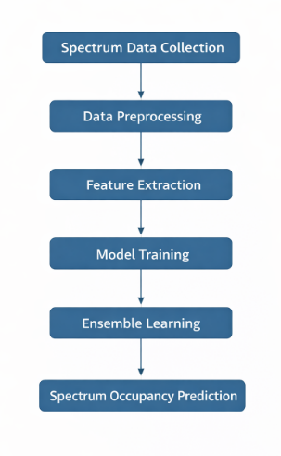
Fig 1 General workflow of the spectrum data analysis
3.2 Dataset Details
The dataset used in this study consists of historical spectrum sensing measurements collected from wireless communication environments. The dataset contains time-series records indicating whether a particular frequency channel is occupied or idle at different time intervals.
Each record typically includes:
- Timestamp
- Channel Frequency
- Signal Strength
- Occupancy Status (0 or 1)
3.3 Research Approach
This study follows an experimental research approach where machine learning models are trained and evaluated using historical spectrum data. The focus is on developing a predictive model capable of forecasting spectrum occupancy accurately.
Chapter 4
Methodology
4.1 Machine Learning Techniques
The proposed system utilizes multiple machine learning algorithms including:
• Logistic regression
• KNN
• SVM
• Decision Tree
• Random Forest
• AdaBoost
• Gradient Boost
•NaiveBayes
These models are trained independently and later combined using an ensemble strategy.
The implementation of the proposed system involves the following steps:
- Import the dataset.
- Perform data preprocessing and cleaning.
- Normalize and transform the data.
- Split the dataset into training and testing sets.
- Train individual machine learning models.
- Combine model outputs using ensemble learning.
- Evaluate model performance.
4.2 Evaluation Metrics
The performance of the proposed model is evaluated using the following metrics:
- Accuracy
Accuracy measures the proportion of correctly predicted instances among the total number of samples.
$$Accuracy=\frac{TP+TN}{TP+TN+FP+FN}$$
- Precision
Precision measures how many of the predicted positive instances are actually positive.
$$Precision=\frac{TP}{TP+FP}$$
- Recall
Recall measures how many actual positive instances are correctly predicted by the model.
$$Recall=\frac{TP}{TP+FN}$$
- F1 Score
F1 Score is the harmonic mean of precision and recall and provides a balanced measure of model performance.
$$F1=\frac{2×Precision×Recall}{Precision+Recall}$$
(OR)

$$F1=\frac{2TP}{2TP+FP+FN}$$
Chapter 5
Implementation And Results
5.1 Setup
The implementation is carried out using Python programming language. The experiments are performed in a cloud-based development environment such as Google Colab. Various machine learning libraries including Scikit-learn, NumPy, and Pandas are used for model development.
5.2 Dataset Preprocessing
Data preprocessing involves removing missing values, normalizing feature values, and transforming the dataset into a suitable format for machine learning algorithms. The dataset is then divided into training and testing subsets.
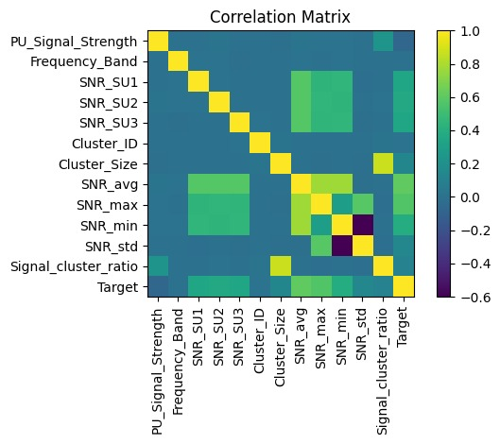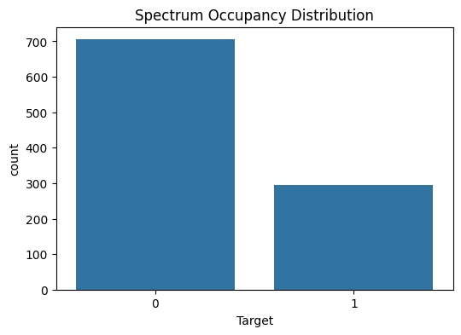
Fig 5.1 Correlation matrix Fig 5.2 Distribution of spectrum occupancy
5.3 Experimental Procedure
Each machine learning model is trained using the training dataset. Hyperparameter tuning is performed to optimize model performance. After training, predictions are generated for the test dataset and combined using ensemble techniques.
5.4 Results

The experimental results demonstrate that the ensemble learning model achieves improved prediction accuracy compared to individual machine learning models. The ensemble model effectively captures temporal patterns in spectrum usage and provides more reliable predictions.

Chapter 6
Result Discussion
6.1 Insights from Results
The experimental results indicate that ensemble learning significantly improves spectrum occupancy prediction performance. By combining multiple models, the system reduces prediction errors and increases robustness. 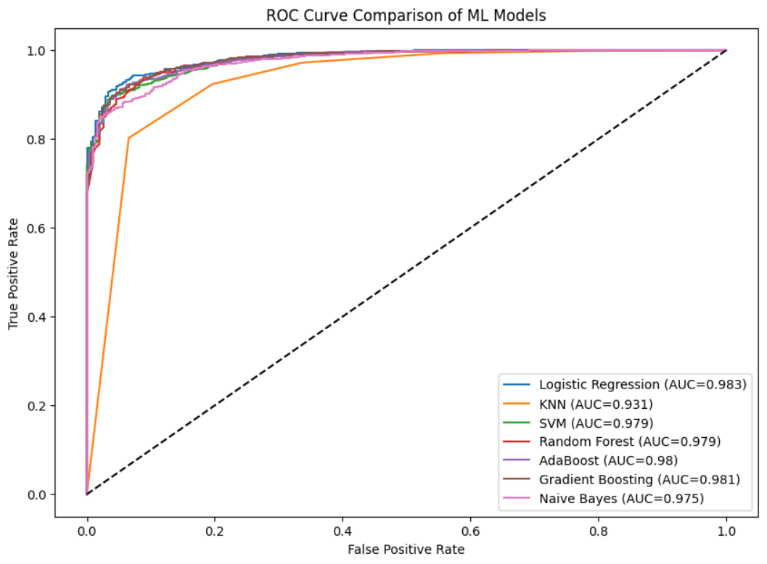 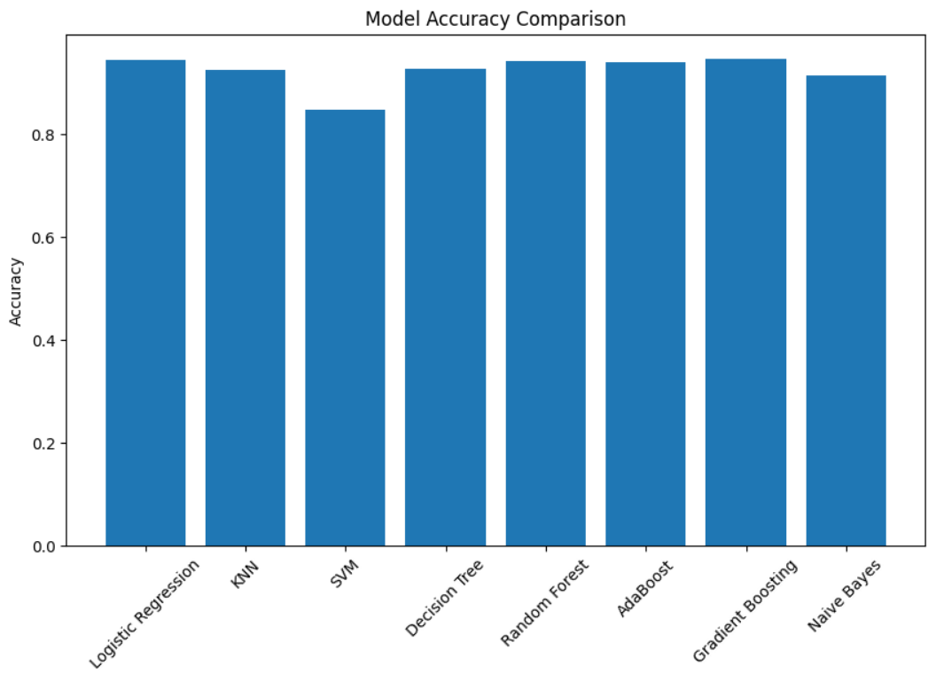
Fig 6.1 Comparison of ROC Curves Fig 6.2 Comparisons of Accuracy
Model | Accuracy
Logistic Regression | 94.35%
KNN | 92.50%
SVM | 84.75%
Decision Tree | 92.70%
Random Forest | 94.25%
Gradient Boosting | 94.60%
Naïve Bayes | 91.35%
AdaBoost | 93.39%
Table 1 Accuracy comparison of different classification models
6.2 Implications
Accurate spectrum prediction enables cognitive radio devices to make better decisions when accessing unused frequency bands. This leads to improved spectrum utilization and reduced interference between users.
6.3 Limitations
The proposed system relies on historical spectrum data and may require retraining when network conditions change significantly. Additionally, large datasets may increase computational complexity.
Chapter 7
Conclusion And Scope For Future Work
7.1 Summary
This project presented an adaptive ensemble machine learning framework for predicting spectrum occupancy in cognitive radio networks. The proposed approach combines multiple machine learning models to improve prediction accuracy and robustness.
7.2 Contributions
The study demonstrates the effectiveness of ensemble learning techniques in modeling time-series spectrum data and improving prediction performance.
7.3 Key Takeaways
• Ensemble learning improves spectrum prediction accuracy.
• Machine learning techniques can effectively model temporal spectrum behavior.
• Cognitive radio networks benefit from predictive spectrum management.
7.4 Future Work
Future research can explore deep learning models such as recurrent neural networks and long short-term memory networks for more advanced spectrum prediction. Additionally, real-time spectrum prediction systems can be developed for practical deployment.
Appendix A
Dataset Description and Pre-Processing Details
A.1 Dataset Description
The dataset used in this project is the CASS Spectrum Dataset, which contains simulated spectrum sensing data used for spectrum occupancy prediction in cognitive radio networks. The dataset consists of 1000 samples and 12 attributes representing different parameters related to primary user activity, signal strength, signal-to-noise ratio, and spectrum sensing performance.
The dataset is used to train and evaluate machine learning models for predicting whether a spectrum band is available or occupied.
A.2 Dataset Features
The dataset includes the following attributes:
Feature | Description
PU_Presence | Indicates whether the Primary User (PU) is present (1) or absent (0)
PU_Signal_Strength | Signal strength of the primary user measured in dBm
Frequency_Band | Frequency band being monitored
SNR_SU1 | Signal-to-noise ratio for Secondary User 1
SNR_SU2 | Signal-to-noise ratio for Secondary User 2
SNR_SU3 | Signal-to-noise ratio for Secondary User 3
Cluster_ID | Identifier representing the sensing cluster
Cluster_Size | Number of nodes in the sensing cluster
Pd | Probability of detection of the primary user
Pfa | Probability of false alarm
Pmd | Probability of missed detection
Target | Final class label indicating spectrum occupancy (0 = Free, 1 = Occupied)
Table 2 Attributes
A.3 Data Pre-Processing
Before applying machine learning algorithms, the dataset was preprocessed to ensure data quality and model performance.
The following preprocessing steps were performed:
- Data Cleaning – The dataset was checked for missing or inconsistent values.
- Feature Selection – Relevant features related to spectrum sensing and signal conditions were selected.
- Normalization – Numerical attributes such as signal strength and SNR values were scaled to improve model performance.
- Dataset Splitting – The dataset was divided into training and testing sets for model evaluation.
- Target Variable Identification – The Target column was used as the output label for spectrum occupancy prediction.
A.4 Dataset Usage in the Proposed Model
The processed dataset is used to train multiple machine learning models including Decision Trees, Support Vector Machines, and ensemble learning techniques. These models analyze historical spectrum sensing data to predict the availability of spectrum channels for secondary users in cognitive radio networks.

References
- M. Yasir, Z. S. Shah, S. A. Memon, and Z. Ali, “Machine learning based analysis of cellular spectrum,” International Journal of Wireless and Microwave Technologies, vol. 11, no. 2, pp. 24–31, 2021.
- B. Keshavamurthy and N. Michelusi, “Learning-based spectrum sensing and access in cognitive radios via approximate POMDPs,” IEEE Transactions on Cognitive Communications and Networking, 2021.
- Y. Zhang and Z. Luo, “A review of research on spectrum sensing based on deep learning,” Electronics, vol. 12, no. 21, 2023.
- X. Wen, S. Fang, Z. Xu, and H. Liu, “Joint multidimensional pattern for spectrum prediction using graph neural networks,” Sensors, vol. 23, no. 21, 2023.
- T. Kolangiyappan, S. Gauni, and P. Chandhar, “Spectrum occupancy prediction using LSTM models for cognitive radio applications,” Network, 2024.
- M. G. Sumithra and M. Suriya, “Improved spectrum prediction model for cognitive radio networks using hybrid deep learning technique,” International Journal of Intelligent Networks, vol. 5, pp. 286–292, 2024.
- S. Mondal, M. P. Dutta, and S. K. Chakraborty, “A hybrid deep learning model for efficient spectrum sensing in cognitive radio,” Journal of Electrical Systems, vol. 20, no. 3, 2024.
- P. Venkatapathi, H. Khan, S. S. Rao, and G. Immadi, “Cooperative spectrum sensing performance assessment using machine learning in cognitive radio sensor networks,” Engineering, Technology & Applied Science Research, vol. 14, no. 1, 2024.
- T. A. Oyewo, U. S. Dauda, and A. S. Mohammed, “Spectrum occupancy prediction using a modified XGBoost machine learning algorithm,” International Conference on Scientific and Academic Research, 2023.
- G. Pan, D. K. Y. Yau, B. Zhou, and Q. Wu, “Deep learning for spectrum prediction in cognitive radio networks: State-of-the-art and future challenges,” 2024.
- S. Haykin, “Cognitive radio: Brain-empowered wireless communications,” IEEE Journal on Selected Areas in Communications.
- T. Yucek and H. Arslan, “A survey of spectrum sensing algorithms for cognitive radio applications,” IEEE Communications Surveys & Tutorials.
- Y. Zeng, Y. Liang, A. Hoang, and R. Zhang, “A review on spectrum sensing for cognitive radio,” IEEE Communications Surveys & Tutorials.
- I. F. Akyildiz, W. Y. Lee, M. C. Vuran, and S. Mohanty, “Next generation dynamic spectrum access cognitive radio networks,” Computer Networks.
- Q. Zhao and B. Sadler, “A survey of dynamic spectrum access,” IEEE Signal Processing Magazine.
[16] K. B. Letaief and W. Chen (2021).“Machine Learning for Wireless Communications in the Internet of Things: A Comprehensive Survey.”IEEE Communications Surveys & Tutorials, vol. 23, no. 3, pp. 1506–1543.
[17] M. Bkassiny, Y. Li, and S. K. Jayaweera (2021).“A Survey on Machine Learning Techniques in Cognitive Radios.”IEEE Communications Surveys & Tutorials, vol. 23, no. 2, pp. 1136–1161.
[18] H. Zhang, Y. Liang, L. Song, and Z. Han (2022).“Machine Learning Based Spectrum Prediction for Cognitive Radio Networks.”IEEE Transactions on Wireless Communications, vol. 21, no. 4, pp. 2578–2590.
[19] S. Wang, J. Zhang, and X. Wang (2022).“Spectrum Occupancy Prediction Using Machine Learning for Cognitive Radio Networks.”IEEE Access, vol. 10, pp. 48752–48763.
[20] A. Al-Hourani and S. Kandeepan (2023).“Data-Driven Spectrum Prediction in Cognitive Radio Networks Using Machine Learning Techniques.”IEEE Access, vol. 11, pp. 30211–30222.
CONTRIBUTION TO SUSTAINABLE DEVELOPMENT GOALS

Title of the Project: ADAPTIVE ENSEMBLE MACHINE LEARNING FRAMEWORK FOR TIME-SERIES SPECTRUM OCCUPANCY PREDICTION IN COGNITIVE RADIO NETWORKS.
Project Member(s) Name & Register Number :
CB.EN.U4ELC24006 – AKSHITA MURALI
CB.EN.U4ELC24058 – SUBASHREE A
CB.EN.U4ELC24014 – DHARSHAVARDHAN UM
CB.EN.U4ELC24031 – S DHEVAN
Guide Name & Designation: Mr NAKKEERAN M – ASSISTANT PROFESSOR (OC)
SDGs | Justification for the Contribution
7. AFFORDABLE AND CLEAN ENERGY | Cognitive radio technology reduces energy waste in communication systems by optimising spectrum usage and improving transmission efficiency.
8. DECENT WORK AND ECONOMIC GROWTH | Intelligent spectrum management improves communication infrastructure and supports innovation-driven economic growth.
9 . INDUSTRY, INNOVATION AND INFRASTRUCTURE | Spectrum analysis using cognitive radios improves wireless communication infrastructure by enabling intelligent and efficient use of the radio frequency spectrum.
11 . SUSTAINABLE CITIES AND COMMUNITIES | Efficient spectrum management through cognitive radios supports reliable communication networks required for smart cities and connected communities.
12. RESPONSIBLE CONSUMPTION AND PRODUCTION | Efficient prediction and utilization of radio spectrum reduces resource wastage and supports responsible consumption of communication resources.



